Title of Document: Welcome to Freemasonry
Purpose of Document: The candidate will no doubt be a little confused as to what has happened, who’s who and what does he do in the short term. The aim of the note is to provide him with the essential information on a single piece of paper.
Notes for use of this Document:
- The document will need modifying to suit your Lodge, the areas that need your attention are highlighted in yellow.
- The document is meant to be folded as a Tri-fold leaflet, hence it looks strange on first view. To make the Trifold leaflet you will need to print it double sided ‘fliping‘ on the short edge. Having printed the document look at the document as pages 1,2,3 facing you as shown below:
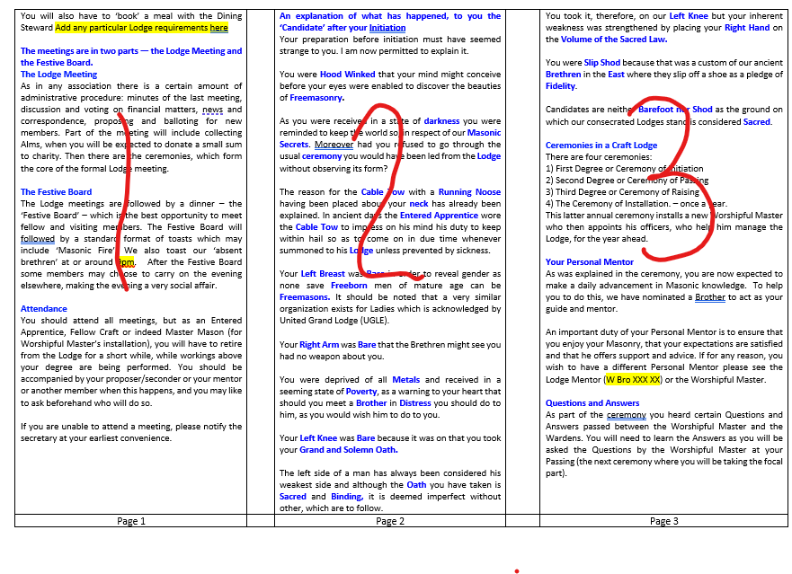 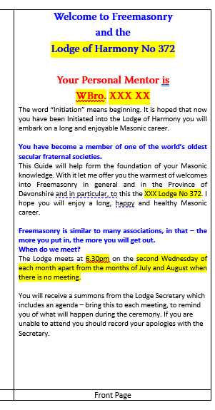 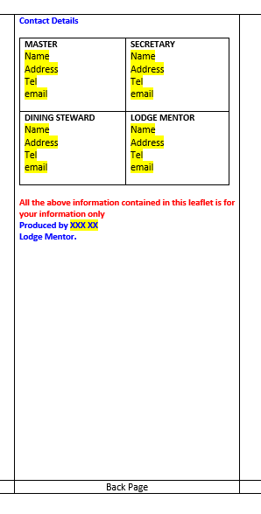
Fold into 3 vertically, with page 3 over page 2 and then page 1 over page 2. You should be now looking at the Front page and if you turn over the Back Page.
- The font for modification is Calibri font size 10.
- You can add more text but due to formatting issues, the new text cannot overlap onto the next page. (For the more advanced user the texts is placed in a table acting as columns).
- If you have trouble modifying please contact mentoring@devonshirefreemasons.org.uk
- It is easier to print the document out if you delete this front page.

Immediate Guidance  To aid your immediate understanding it is recommended that you read the booklet The Initiate’s Guide and the leaflet An Explanation of the First Degree Ceremony.  Future Reading  During the ceremony you received the following books, these are for your future reference:  - Book of Constitutions  - Notes for guidance of members of the Craft  - Masonic Charities  - Bye-laws of the Lodge  The Chisel Club  The Province has a social club for New Masons, their families, friends and it is known as the Chisel Club. The club meets four times a year in Plymouth, Exeter, Torbay and East Devon. Two of these meetings are activities which are chosen by the members of the club and range from Go Karting to Clay Pigeon Shooting. The remaining two meetings are normally held to coincide with one of the Membership Team candidate social events, where you will get to meet potential and new Masons, allowing you to increase your friendship circle and if wanted Masonic visiting.  The club has an aspiration to eventually reach North Devon, but all events are open to North Devon Masons wherever they are held.  For more information please email: info@thechiselclub.org.uk or visit the website: www.thechiselclub.org.uk  At the request of the members, the Facebook page is hidden, in order to gain access, please enquire through the email address above. |  | Contact Details  All the above information contained in this leaflet is for your information only  Produced by XXX XX  Lodge Mentor. |  | Welcome to Freemasonry  and the  XXX Lodge No XXX  Your Personal Mentor is  WBro. XXX XX  The word “Initiation” means beginning. It is hoped that now you have been Initiated into the XXX Lodge you will embark on a long and enjoyable Masonic career.  You have become a member of one of the world’s oldest fraternal societies.  This Guide will help form the foundation of your Masonic knowledge. With it let me offer you the warmest of welcomes into Freemasonry in general and in the Province of Devonshire and in particular, to this the XXX Lodge No 372. I hope you will enjoy a long, happy and healthy Masonic career.  Freemasonry is similar to many associations, in that – the more you put in, the more you will get out.  When do we meet?  The Lodge meets at 6.30pm on the second Wednesday of each month apart from the months of July and August when there is no meeting.  You will receive a summons from the Lodge Secretary which includes an agenda – bring this to each meeting, to remind you of what will happen during the ceremony. If you are unable to attend you should record your apologies with the Secretary.
  MASTER  Name  Address  Tel  email | SECRETARY  Name  Address  Tel  email
  DINING STEWARD  Name  Address  Tel  email | LODGE MENTOR  Name  Address  Tel  email
Page 4 |  | Back Page |  | Front Page
Welcome to Freemasonry Gen v1.0

You will also have to ‘book’ a meal with the Dining Steward Add any particular Lodge requirements here  The meetings are in two parts — the Lodge Meeting and the Festive Board.  The Lodge Meeting  As in any association there is a certain amount of administrative procedure: minutes of the last meeting, discussion and voting on financial matters, news and correspondence, proposing and balloting for new members. Part of the meeting will include collecting Alms, when you will be expected to donate a small sum to charity. Then there are the ceremonies, which form the core of the formal Lodge meeting.  The Festive Board  The Lodge meetings are followed by a dinner – the ‘Festive Board’ – which is the best opportunity to meet fellow and visiting members. The Festive Board will be followed by a standard format of toasts which may include ‘Masonic Fire’. We also toast our ‘absent brethren’ at or around 9pm. After the Festive Board some members may choose to carry on the evening elsewhere, making the evening a very social affair.  Attendance  You should attend all meetings, but as an Entered Apprentice, Fellow Craft or indeed Master Mason (for Worshipful Master’s installation), you will have to retire from the Lodge for a short while, while workings above your degree are being performed. You should be accompanied by your proposer/seconder or your mentor or another member when this happens, and you may like to ask beforehand who will do so.  If you are unable to attend a meeting, please notify the secretary at your earliest convenience. |  | An explanation of what has happened, to you the ‘Candidate’ after your Initiation  Your preparation before initiation must have seemed strange to you. I am now permitted to explain it.  You were Hood Winked that your mind might conceive before your eyes were enabled to discover the beauties of Freemasonry.  As you were received in a state of darkness you were reminded to keep the world so, in respect of our Masonic Secrets. Moreover had you refused to go through the usual ceremony you would have been led from the Lodge without observing its form?  The reason for the Cable Tow with a Running Noose having been placed about your neck has already been explained. In ancient days the Entered Apprentice wore the Cable Tow to impress on his mind his duty to keep within hail so as to come on in due time whenever summoned to his Lodge unless prevented by sickness.  Your Left Breast was Bare in order to reveal gender as only men of mature age can be made Freemasons. It should be noted that a very similar organisation exists for Ladies.  Your Right Arm was Bare that the Brethren might see you had no weapon about you.  You were deprived of all Metals and received in a seeming state of Poverty, as a warning to your heart that should you meet a Brother in Distress you should do to him, as you would wish him to do to you.  Your Left Knee was Bare because it was on that you took your Grand and Solemn Oath.  The left side of a man has always been considered his weakest side and although the Oath you have taken is Sacred and Binding, it is deemed imperfect without other, which are to follow. |  | You took it, therefore, on our Left Knee but your inherent weakness was strengthened by placing your Right Hand on the Volume of the Sacred Law.  You were Slip Shod because that was a custom of our ancient Brethren in the East where they slip off a shoe as a pledge of Fidelity.  Candidates are neither Barefoot nor Shod as the ground on which our consecrated Lodges stand is considered Sacred.  Ceremonies in a Craft Lodge  There are four ceremonies:  1) First Degree or Ceremony of Initiation  2) Second Degree or Ceremony of Passing  3) Third Degree or Ceremony of Raising  4) The Ceremony of Installation. – once a year.  This latter annual ceremony installs a new Worshipful Master who then appoints his officers, who help him manage the Lodge, for the year ahead.  Your Personal Mentor  As was explained in the ceremony, you are now expected to make a daily advancement in Masonic knowledge. To help you to do this, we have nominated a Brother to act as your guide and mentor.  An important duty of your Personal Mentor is to ensure that you enjoy your Masonry, that your expectations are satisfied and that he offers support and advice. If for any reason, you wish to have a different Personal Mentor please see the Lodge Mentor (W Bro XXX XX) or the Worshipful Master.  Questions and Answers  As part of the ceremony you heard certain Questions and Answers passed between the Worshipful Master and the Wardens. You will need to learn the Answers as you will be asked the Questions by the Worshipful Master at your Passing (the next ceremony where you will be taking the focal part).
Page 1 |  | Page 2 |  | Page 3

